**MACHINE LEARNING REPORT**

 I have chosen to work with the Titanic dataset. I will also focus on doing some illustrative data visualizations along the way. I’ll then use Binomial Linear model to create a model predicting survival on the Titanic.

There are three parts to my script as follows:

* Feature engineering
* Missing value imputation
* Prediction

Analysis

From the dataset titanic the total observations are 891 and 12 variables.

#Summary age



The highest age of the passengers is 80 years and average age is 29years

The missing data is shown in the above fig

The survival count is less than the people survived

More 1st class reservation ticket people survived compared to other class passengers.

male factor passengers are more compared to female passengers

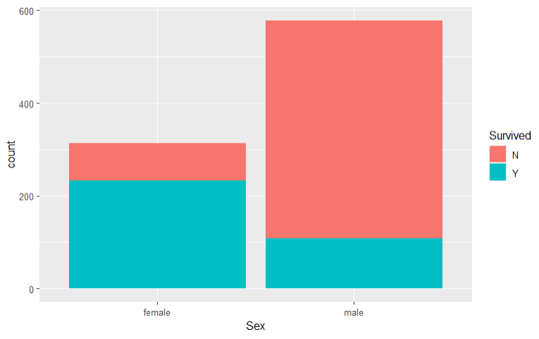

Survival of female are more compared to male survivals.

First class male passengers are more, and female passengers are more compared to other class reservation.

The frequency age between 20- and 30-years passengers are more in the ship compared to other age people.

In the above boxplot also, we can see that age group is between 20- 35 and female and male almost same frequency.

Summary of predicted survival, fare, age are displayed above.

since the survival values range from 1 to 0, where 1 = survived and 0 = died

The above data frame describes which gender, age, price which effects the survival of the passenger.

Reference

<https://www.kaggle.com/c/titanic/data>